koneksi.php

<?php

$servername = "localhost";
$username = "root";
$password = "";
$db = "distribusi_lks";

$koneksi = mysqli_connect($servername, $username, $password,$db);

if (!$koneksi) {
die("Connection failed: " . mysqli_connect_error());
}
?>

tambah_barang.php (tambah stok)

<!DOCTYPE html>
<head>
<title>Tambah Stok LKS</title>
<script language="javascript">
function cekform(){

if(document.form_input_lks.txtnama.value==""){
alert('Kode Harus Diisi');
document.form_input_lks.txt_kode.focus();
return false;
} else if(document.form_input_lks.txt_harga.value==""){
alert('Harga Harus Diisi');
document.form_input_lks.txt_harga.focus();
return false;
} else if(document.form_input_lks.txt_jumlah.value==""){
alert('Persediaan Barang Harus Diisi');
document.form_input_lks.txt_jumlah.focus();
return false;
} else {
return true;
}
}
</script>
</head>

<body>
<a href="tampilan_data_stok.php">Lihat Stok</a>
<center>
<h2>Form Input Data Stok LKS</h2>
<form action="" method="post" name="form_input_lks" onsubmit="return cekform()">
<table width="30%" border="1">
<tr>
<td>Kode </td>
<td><input name="txt_kode" type="text" id="txt_kode" /></td>
</tr>
<tr>
<td>
<label for="kelas">Kelas</label>
</td>
<td>
<select name="slct_kelas">
<option value="1">1</option>
<option value="2">2</option>
<option value="3">3</option>
<option value="4">4</option>
<option value="5">5</option>
<option value="6">6</option>
</select>

</td>
</tr>
<tr>
<td>Jumlah </td>
<td><input name="txt_jumlah" type="text" id="txt_jumlah" /></td>
</tr>
<tr>
<td>Harga</td>
<td><input name="txt_harga" type="text" id="txt_harga"/></td>
</tr>

<tr>
<td>&nbsp;</td>
<td><input name="btn_simpan" type="submit" id="btn_simpan" value="Tambah Stok" /></td>
</tr>
</table>
</form>

</center>
</body>
</html>
<?php

include "koneksi.php";
if(isset($_POST['btn_simpan'])){
$kode = $_POST['txt_kode'];
$kelas = $_POST['slct_kelas'];
$jumlah = $_POST['txt_jumlah'];
$harga = $_POST['txt_harga'];
$persediaan = $jumlah * $harga;

$sql = "INSERT INTO tb_stok_lks VALUES('$kode','$kelas','$jumlah','$harga','$persediaan')";
$kueri = mysqli_query($koneksi, $sql);
if($kueri){
echo "<script>alert('Data barang berhasil dimasukkan ke database')</script>";
} else {
echo "<script>alert('Data barang gagal dimasukkan ke database')</script>";

echo mysqli_error($koneksi);
}
}
?>
edit_barang.php (edit stok)

<?php
include "koneksi.php";

if(isset($_GET['id'])){
$kode = $_GET['id'];
} else {

echo "<script>alert('Kode Barang Belum Dipilih');document.location='tampilan_data_stok.php'</script>";
}

$sql = "SELECT * FROM tb_stok_lks WHERE id='$kode'";
$kueri = mysqli_query($koneksi, $sql);
$data = mysqli_fetch_array($kueri);

$kode = $data['id'];
$kelas = $data['kelas'];
$jumlah = $data['jumlah'];
$harga = $data['harga'];
$persediaan = $data['nilai_persediaan'];
?>
<!-- sekarang bikin formnya -->
<html>
<head><title>Edit Data Barang</title>
<script language="javascript">
function cekform(){

if(document.form_input_lks.txtnama.value==""){
alert('Kode Harus Diisi');
document.form_input_lks.txt_kode.focus();
return false;
} else if(document.form_input_lks.txt_harga.value==""){
alert('Harga Harus Diisi');
document.form_input_lks.txt_harga.focus();
return false;
} else if(document.form_input_lks.txt_jumlah.value==""){
alert('Persediaan Barang Harus Diisi');
document.form_input_lks.txt_jumlah.focus();
return false;
} else {
return true;
}
}
</script>
</head>
<body>
<a href="tampilan_data_stok.php">Lihat Stok</a>
<center>
<h2>Form Edit Data Stok LKS</h2>
<form action="" method="post" name="frmbarang" onsubmit="return cekform()">
<table width="500" border="1">
<tr>
<td width="163">Kode Barang </td>
<td width="321"><input name="txt_kode" type="text" id="txt_kode" size="5" maxlength="5" value="<?php echo $kode ?>" readonly/></td>
</tr>
<tr>
<td>
<label for="kelas">Kelas</label>
</td>
<td>
<select name="slct_kelas">
<option value="<?php echo $kelas?>"><?php echo $kelas?></option>
<option value="1">1</option>
<option value="2">2</option>
<option value="3">3</option>
<option value="4">4</option>
<option value="5">5</option>
<option value="6">6</option>
</select>
</td>
</tr>
<tr>
<td>Jumlah</td>
<td><input name="txt_jumlah" type="text" id="txt_jumlah" value="<?php echo $jumlah?>"/></td>
</tr>
<tr>
<td>Harga</td>
<td><input name="txt_harga" type="text" id="txt_harga" value="<?php echo $harga?>"/></td>
</tr>
<tr>
<td>Nilai Persediaan</td>
<td><input name="txt_persediaan" type="text" id="txt_persediaan" value="<?php echo $persediaan?>"readonly/></td>
</tr>
<tr>
<td>&nbsp;</td>
<td><input name="tblEdit" type="submit" id="tblEdit" value="Edit Barang" /></td>
</tr>
</table>
</form>
</body>
</center>
</html>
<?php

if(isset($_POST['tblEdit'])){

$kode = $_POST['txt_kode'];
$kelas = $_POST['slct_kelas'];
$jumlah = $_POST['txt_jumlah'];
$harga = $_POST['txt_harga'];
$persediaan = $_POST['txt_persediaan'];

$sql = "UPDATE tb_stok_lks SET kelas='$kelas', harga='$harga', jumlah='$jumlah', nilai_persediaan='$persediaan' WHERE id='$kode'";
$kueri = mysqli_query($koneksi, $sql);

if($kueri){
echo "<script>alert('Data barang berhasil diedit'); document.location='tampilan_data_stok.php'</script>";
} else {
echo "<script>alert('Data barang gagal diedit')</script>";
echo mysqli_error();
}
}
?>
delete.php (delete stok)

<?php
if(isset($_GET['id'])){
include "koneksi.php";
$kode = $_GET['id'];
$sql = "DELETE FROM tb_stok_lks WHERE id='$kode'";
$kueri = mysqli_query($koneksi, $sql);
if($kueri){
echo "<script>alert('Data barang berhasil dihapus');document.location='tampilan_data_stok.php'</script>";
} else{
echo "<script>alert('Data barang Gagal dihapus');document.location='tampilan_data_stok.php'</script>";
}
} else {
echo "<script>alert('Kode Barang Belum Dipilih');document.location='tampilan_data_stok.php'</script>";
}
?>

tampilan_data_stok.php

<!DOCTYPE html>
<head>
<title>Riwayat Input Stok LKS</title>
</head>

<body>
<!-- <?php
include "tambah_barang.php";
?> -->
<a href="tambah_barang.php">Tambah Stok</a>
|
<a href="tambah_distribusi.php">Lihat Distribusi</a>
<center>
<table width="519" border="1">
<caption align="top">
<h2>Riwayat Input Stok LKS</h2>
</caption>
<tr>
<th width="25" scope="col">No</th>
<th width="103" scope="col">Kode </th>
<th width="128" scope="col">Kelas </th>
<th width="60" scope="col">Jumlah</th>
<th width="81" scope="col">Nilai Persediaan</th>
<th width="82" scope="col">Action Edit</th>
<th width="82" scope="col">Action Delete</th>
</tr>
<?php

include "koneksi.php";
$sql = "SELECT * FROM tb_stok_lks";
$kueri = mysqli_query($koneksi, $sql);
$no = 1;
while($data = mysqli_fetch_array($kueri)){
?>
<tr>
<td><?php echo $no?></td>
<td><?php
echo $data['id']?></td>
<td><?php echo $data['kelas']?></td>
<td><?php echo $data['jumlah'];?></td>
<td><?php echo $data['nilai_persediaan']?></td>
<td><!-- buat link untuk edit dan delete dan berikan parameter dgn nama "kode"--><a href="edit_barang.php?id=<?php echo $data['id']?>">Edit</a> </td><td><a href="delete.php?id=<?php echo $data['id']?>">Delete</a></td>
</tr>
<?php
$no++;}
?>
</table>
<table>
<tr>
<td>Jumlah LKS keseluruhan : </td>
<td><?php
$result = mysqli_query($koneksi, 'SELECT SUM(jumlah) AS total_jumlah FROM tb_stok_lks');
$row = mysqli_fetch_assoc($result);
$sum = $row['total_jumlah'];
echo $sum;
?></td>
</tr>
<tr>
<td>Total Nilai Persediaan : </td>
<td>
<?php
$result = mysqli_query($koneksi, 'SELECT SUM(nilai_persediaan) AS total_persediaan FROM tb_stok_lks');
$row = mysqli_fetch_assoc($result);
$total_persediaan = $row['total_persediaan'];
echo $total_persediaan;
?>
</td>
</tr>
</table>
</center>
</body>
</html>
tambah_distribusi.php

<?php
include 'koneksi.php';
$kode = '';
if(isset($_GET['id'])){
$kode = $_GET['id'];
}
$sql = "SELECT * FROM tb_sekolah WHERE id='$kode'";
$kueri = mysqli_query($koneksi, $sql);
$data = mysqli_fetch_array($kueri);

$kode = $data['id'];
$sekolah = $data['nama_sekolah'];
$kelas = $data['kelas'];
$jumlah = $data['jumlah'];
?>
<!DOCTYPE html>
<head>
<title>Tambah Data Barang</title>
<script language="javascript">
function cekform(){

if(document.form_input_lks.txt_sekolah.value==""){
alert('Nama Sekolah Harus Diisi');
document.form_input_lks.txt_sekolah.focus();
return false;
} else if(document.form_input_lks.txt_jumlah.value==""){
alert('Jumlah Harus Diisi');
document.form_input_lks.txt_jumlah.focus();
return false;
} else {
return true;
}
}
</script>
</head>

<body>
<a href="tampilan_data_stok.php">Lihat Stok</a>
<center>
<h2>Form Input Data Distribusi</h2>
<form action="" method="post" name="form_input_lks" onsubmit="return cekform()">
<table width="30%" border="0">
<tr>
<td width="163">Kode </td>
<td width="321"><input name="txt_kode" type="text" id="txt_kode" size="5" maxlength="5" value="<?php echo $kode ?>"/></td>
</tr>
<tr>
<td>Nama Sekolah</td>
<td><input name="txt_sekolah" type="text" id="txt_sekolah" value="<?php echo $sekolah?>"/></td>
</tr>
<tr>
<td>
<label for="kelas">Kelas</label>
</td>
<td>
<select name="slct_kelas">
<option value="<?php echo $kelas?>"><?php echo $kelas?></option>
<option value="1">1</option>
<option value="2">2</option>
<option value="3">3</option>
<option value="4">4</option>
<option value="5">5</option>
<option value="6">6</option>
</select>
</td>
</tr>
<tr>
<td>Jumlah </td>
<td><input name="txt_jumlah" type="text" id="txt_jumlah" value="<?php echo $jumlah?>" /></td>
</tr>
<tr>
<td>&nbsp;</td>
<td><input name="btn_simpan" type="submit" id="btn_simpan" value="Tambah" /> <input name="btn_edit" type="submit" id="btn_edit" value="Edit" /></td>

</tr>
</table>
</form>
</center>
</body>
</html>
<?php

include "koneksi.php";
if(isset($_POST['btn_simpan'])){
$kode = $_POST['txt_kode'];
$kelas = $_POST['slct_kelas'];
$sekolah = $_POST['txt_sekolah'];
$jumlah = $_POST['txt_jumlah'];

$sql = "INSERT INTO tb_sekolah VALUES('$kode','$sekolah','$kelas','$jumlah')";
$kueri = mysqli_query($koneksi, $sql);
if($kueri){
echo "<script>alert('Data Distribusi Sekolah berhasil dimasukkan ke database')</script>";
} else {
echo "<script>alert('Data barang gagal dimasukkan ke database')</script>";
echo mysqli_error($koneksi);
}
}
else if(isset($_POST['btn_edit'])){

$kode = $_POST['txt_kode'];
$sekolah = $_POST['txt_sekolah'];
$kelas = $_POST['slct_kelas'];
$jumlah = $_POST['txt_jumlah'];

$sql = "UPDATE `tb_sekolah` SET `nama_sekolah`='$sekolah',`kelas`='$kelas',`jumlah`='$jumlah' WHERE id = '$kode' ";
$kueri = mysqli_query($koneksi, $sql);
if($kueri){
echo "<script>alert('Data barang berhasil diedit');document.location='tambah_distribusi.php'</script>";
} else {
echo "<script>alert('Data barang gagal diedit');</script>";
echo mysqli_error($koneksi);
}
}
?>
<?php
include 'distribusi.php';
?>
distribusi.php

<!DOCTYPE html>
<head>
<title>Distribusi</title>
</head>

<body>
<center>
<table width="519" border="1">
<caption align="top">
<h2>Data Distribusi</h2>
</caption>
<tr>
<th width="25" scope="col">No</th>
<th width="103" scope="col">Kode </th>
<th width="128" scope="col">Nama Sekolah </th>
<th width="60" scope="col">Kelas</th>
<th width="81" scope="col">Jumlah</th>
<th width="82" scope="col">Action Edit</th>
<th width="82" scope="col">Action Delete</th>
</tr>
<?php

include "koneksi.php";
$sql = "SELECT * FROM tb_sekolah";
$kueri = mysqli_query($koneksi, $sql);
$no = 1;
while($data = mysqli_fetch_array($kueri)){
?>
<tr>
<td><?php echo $no?></td>
<td><?php
echo $data['id']?></td>
<td><?php echo $data['nama_sekolah']?></td>
<td><?php echo $data['kelas'];?></td>
<td><?php echo $data['jumlah']?></td>
<td><a href="tambah_distribusi.php?id=<?php echo $data['id']?>">Edit</a> </td><td><a href="delete_distribusi.php?id=<?php echo $data['id']?>">Delete</a></td>
</tr>
<?php
$no++;}
?>
</table>
<!-- <table>
<tr>
<td>Jumlah LKS keseluruhan : </td>
<td><?php
$result = mysqli_query($koneksi, 'SELECT SUM(jumlah) AS total_jumlah FROM tb_stok_lks');
$row = mysqli_fetch_assoc($result);
$sum = $row['total_jumlah'];
echo $sum;
?></td>
</tr>
<tr>
<td>Total Nilai Persediaan : </td>
<td>
<?php
$result = mysqli_query($koneksi, 'SELECT SUM(nilai_persediaan) AS total_persediaan FROM tb_stok_lks');
$row = mysqli_fetch_assoc($result);
$total_persediaan = $row['total_persediaan'];
echo $total_persediaan;
?>
</td>
</tr>
</table> -->
</center>
</body>
</html>
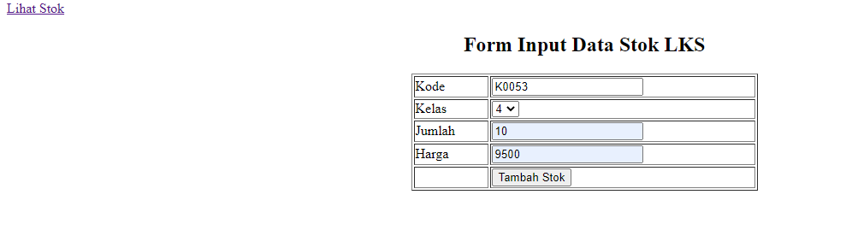



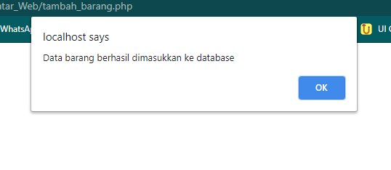
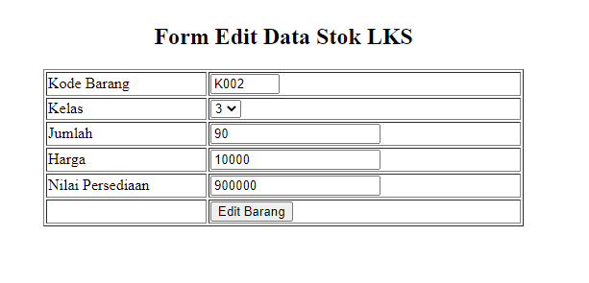

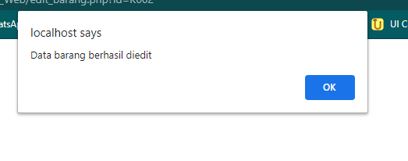
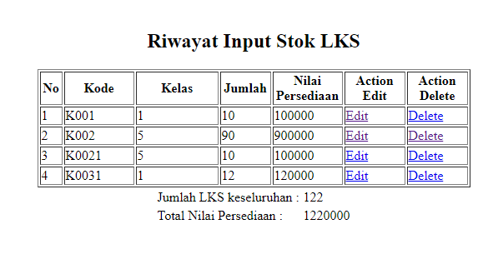

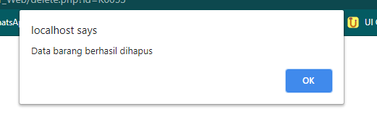
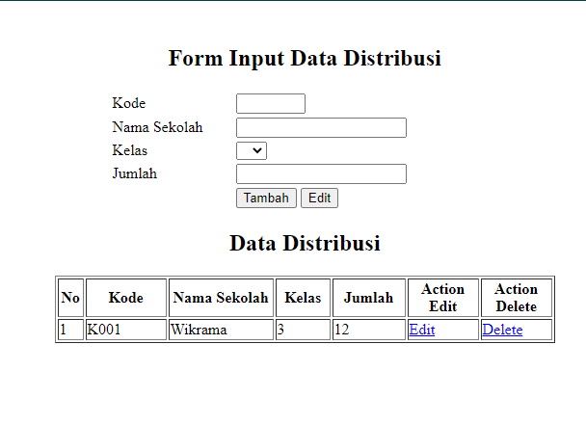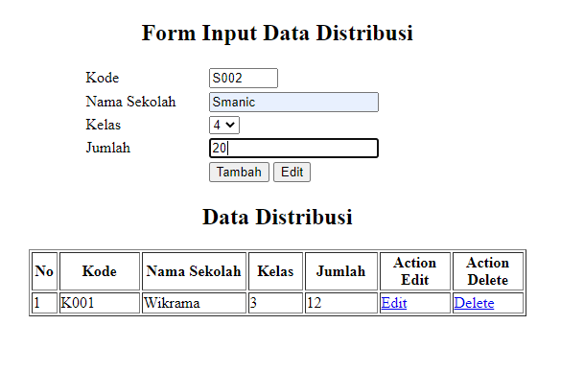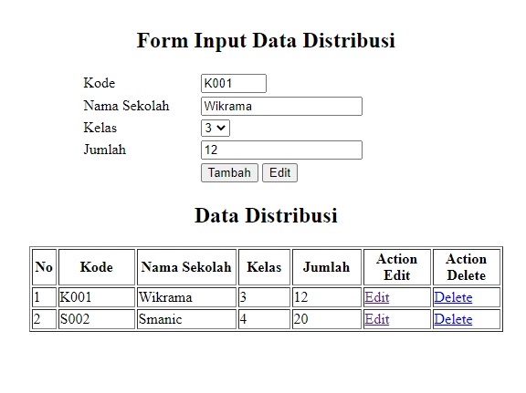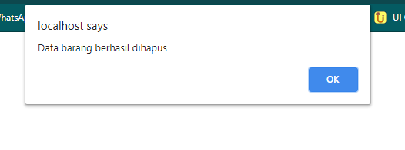
delete_distribusi.php

<?php

if(isset($_GET['id'])){
include "koneksi.php";
$kode = $_GET['id'];
$sql = "DELETE FROM tb_sekolah WHERE id='$kode'";
$kueri = mysqli_query($koneksi, $sql);
if($kueri){
echo "<script>alert('Data barang berhasil dihapus');document.location='tambah_distribusi.php'</script>";
} else{
echo "<script>alert('Data barang Gagal dihapus');document.location='tambah_distribusi.php'</script>";
}
} else {
echo "<script>alert('Kode Barang Belum Dipilih');document.location='tambah_distribusi.php'</script>";
}
?>

